**Nagarjuna College of Engineering and Technology**

( Autonomous Institution, Affiliated to VTU )

Near Mudugurki, Venaktagiri Kote Post, Bengaluru - 562110

**A CCE-2 Report on**

**Personas of Career Coaches & Interview Questions for E-Commerce App Users**

**COURSE**: UI/UX

**COURSE CODE**: 22IST636

**SUBMITTED BY:**

**NAME USN**

Sindhu P L 1NC22IS055

**SUBMITTED TO:**

**Mrs.Yadvika Asst.Professor Dept. of ISE, NCET**

# Table of Contents

1. Introduction
2. Objectives
3. Methodology
4. Career Coach Personas
5. Interview Questions (User Feedback)
6. Conclusion
7. References

# Introduction:

# The modern job market is evolving rapidly, and employment opportunities have broadened beyond traditional roles. Career coaches play a crucial role in helping individuals navigate these changes, discover their passions, and make informed decisions. This report explores the emergence of distinct career coach personas to understand their drives, goals, obstacles, and strategies. By doing so, we aim to enhance the development of tools, platforms, and services that prioritize user-centered career guidance and counseling.

# Objectives:

-To identify and describe the shared characteristics of career coaches both in India and across the globe.

- To develop data-driven personas that represent various types of career coaches.

- To investigate the tools, technologies, and platforms that these professionals use.

- To analyze the challenges and incentives that shape their approaches.

- To gather feedback from real users to improve persona development and user engagement.

# Methodology:

. Secondary Research: Examined various online resources, including LinkedIn profiles, career coaching websites, interviews, TED Talks, blogs, and videos.

• Persona Development Framework: Constructed using templates that include categories such as background, challenges, aspirations, personality traits, and technology utilization.

• User Feedback: Engaged in interviews and informal conversations with students, parents, and coaching clients to confirm the personas.

• Tools Used: Employed Canva for designing personas, Google Forms for conducting interviews, and Notion for organizing information.

# Career Coach Personas:

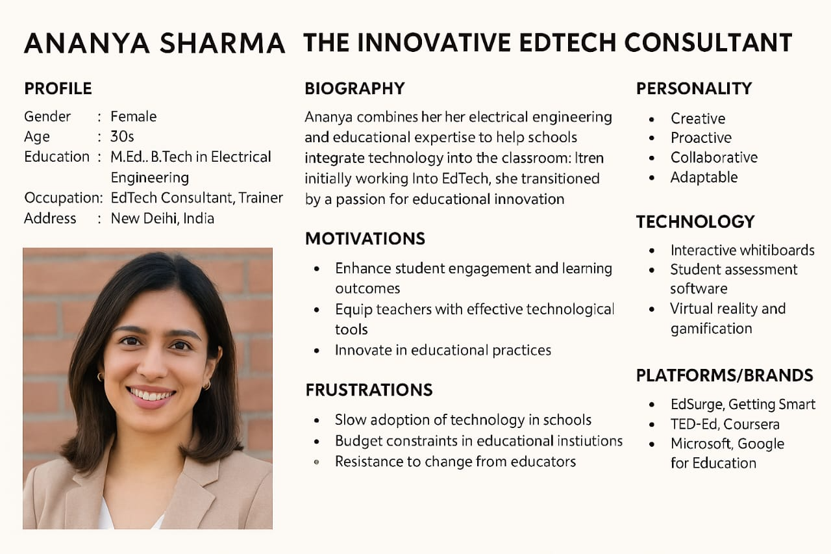

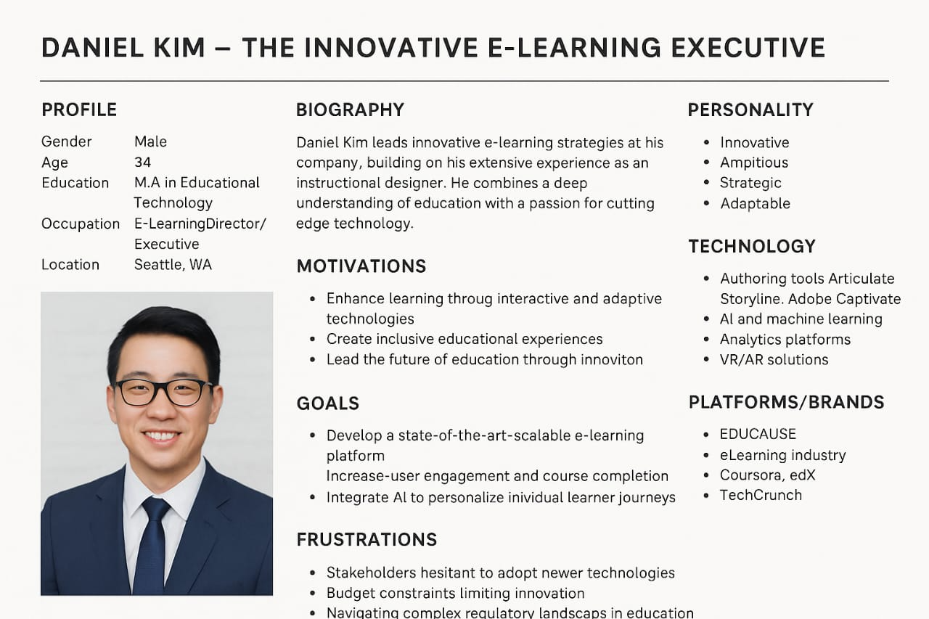

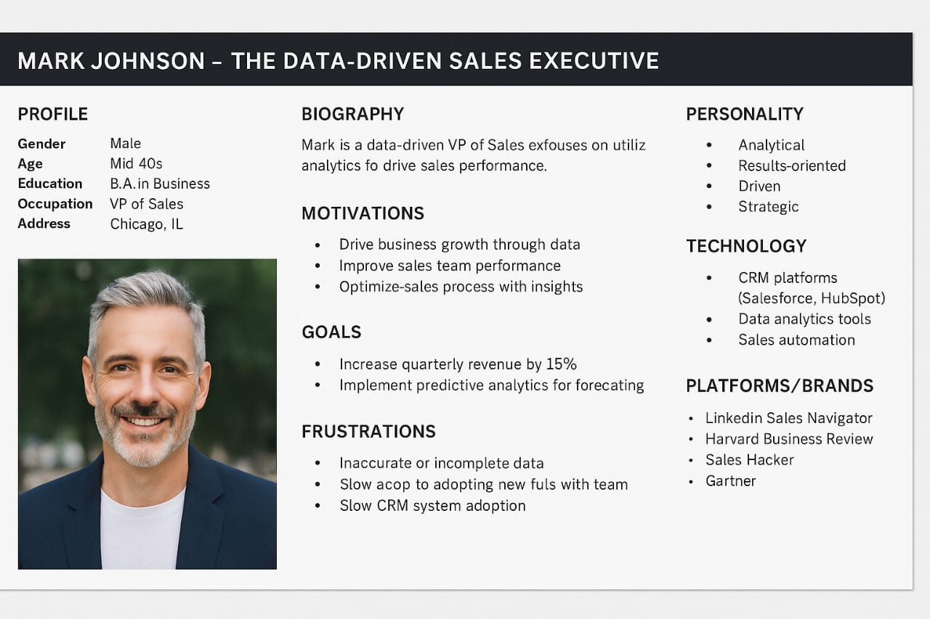

**5.Interview Questions:**

1. Did you face any bugs or issues while registering or logging in?

2. Was the OAuth or social login process smooth and reliable?

3. Did password reset or multi-factor authentication behave as expected?

4. Were there any issues related to user session persistence or cookie behavior?

5. Did the cart and checkout process work smoothly without data loss?

6. Were you redirected properly after payment, or did you face any issues in payment gateway integrations?

7. Did you encounter any issues with promo code validation or application?

8. Was the invoice/receipt generation accurate and timely?

9. Were in-app and email notifications triggered at the right moments?

10. Did push notifications behave differently on Android vs iOS (if applicable)?

11. Were there any delays or failures in order status updates?

12. Was it easy to report a bug or give feedback through the app?

13. Did the feedback form have technical fields (like logs, screenshots) that were useful for reporting?

14. How responsive was the technical team to the issues you reported?

15. Do you think any feature could use better logging or analytics for debugging?

# 6.Conclusion:

# Developing detailed personas for career coaches offers a valuable framework for understanding the diverse strategies, challenges, and motivations influencing career guidance professionals. These personas can aid in creating improved tools, elevate user experiences in career planning applications or platforms, and result in more customized and effective coaching. The research also highlights the growing demand for innovative, technology-assisted, and empathetic career solutions, especially for younger populations and marginalized communities.

# 7.References:

. Nielsen Norman Group – Research-based guidelines on user experience and personas

. UX Collective – Articles and case studies on user-centered design approaches

. Baymard Institute – Usability research specific to e-commerce platforms

. Statista – Reports and data on e-commerce user behavior and trends

. Smashing Magazine – Expert articles on UI/UX design and usability

. UX Planet – Insights into persona development and mobile-first design

. Think with Google – Consumer behavior insights and mobile commerce trends

. Adobe XD Ideas – Best practices in user experience and interface design

. Interaction Design Foundation – Educational content on UX principles and methods

. Google Scholar – Academic publications on interface design and user behavior